1. **Git-HOL**

**Step 1: Setup your machine with Git Configuration**

1. To check if Git client is installed properly  
  
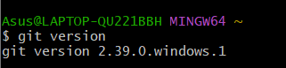

2. To configure user level configuration of user ID and email ID execute

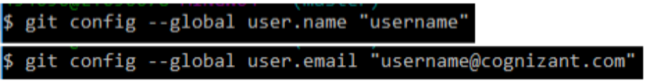  
  
3. To check if the configuration is properly set

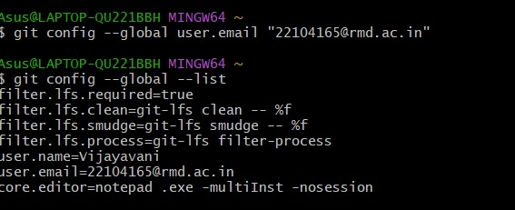

**Step 2: Integrate notepad++.exe to Git and make it a default editor**

1. To check, if notepad.exe execute from git bash  
  


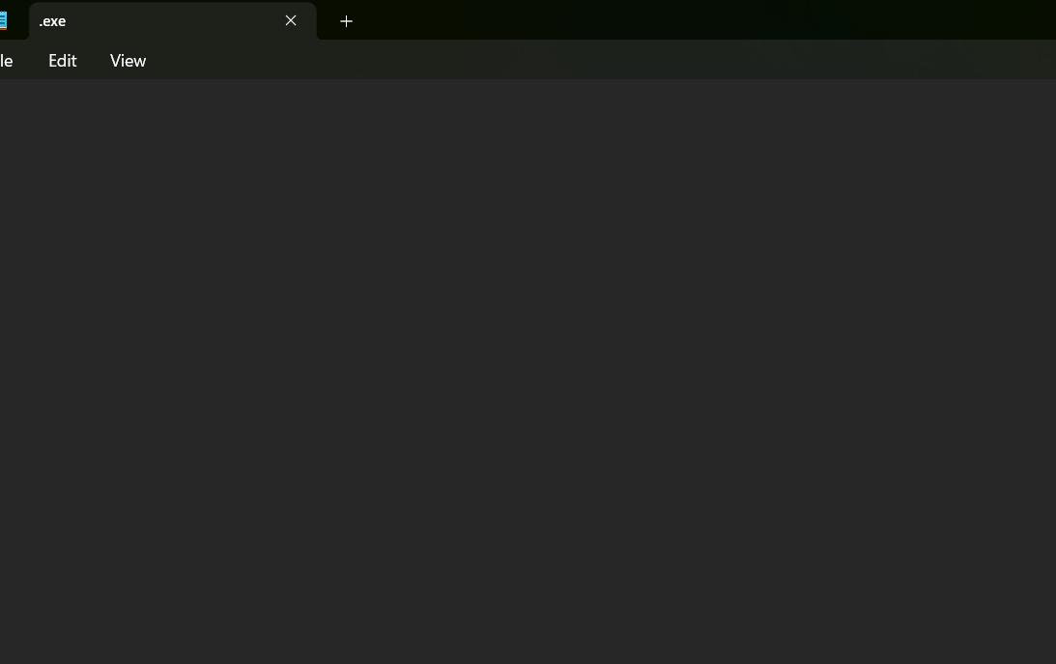

**Step 3: Add a file to source code repository**

1.Open Git bash shell and create a new project “GitDemo” by executing the command

2.To initialize git repository named “GitDemo”

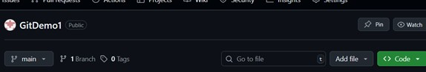

3. To create a file “welcome.txt” and add content to the file  
   
 **welcome to the version control**

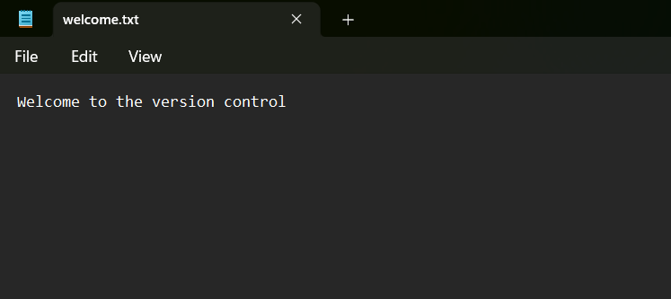

4. To verify if the file “welcome.txt” is created



5. To verify the content

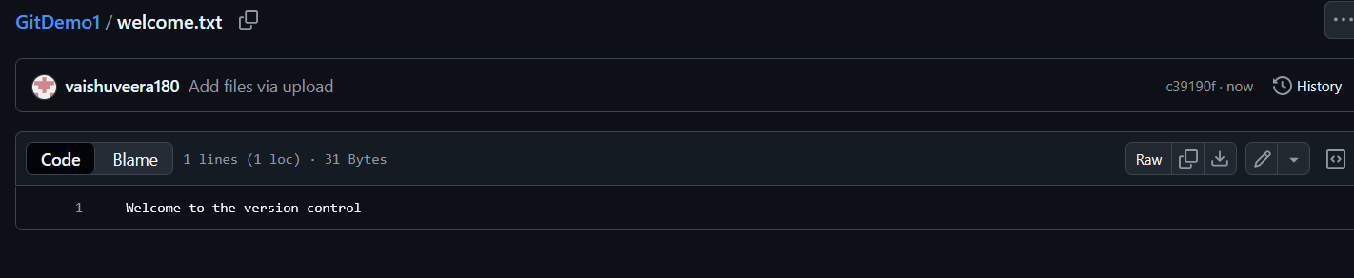

6. Check the status

